Triangle Construction-Questions
Key Stage 3: 2003 Paper 1 Level 3-5
1.
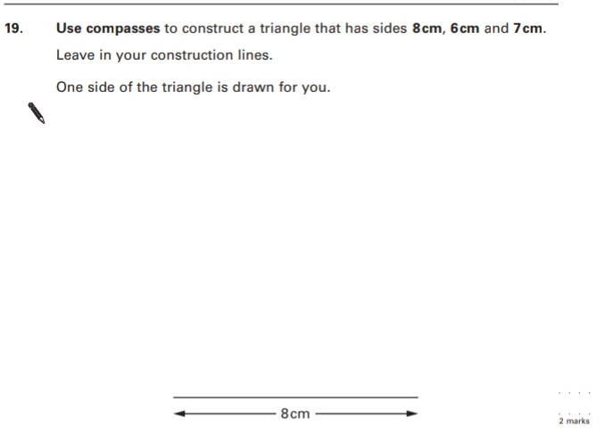
Key Stage 3: 2003 Paper 1 Level 4-6
2.
